FIRM F Fomela – Strategic Action Plan
ESR Assignment-Year 2

  - Date of submission: 11/06/2026
  - Lecturer: Wim Havens
  - Names: Ingrid Patiurca (1090803), Malina Zarughevici (1093352), Oleksandr Nerush(1090552), Yefym Butov (1096451)
  - Version: 1st

Contents
FIRM F Fomela – Strategic Action Plan 1
1. Vision for the Future 3
2. Baseline Analysis – SDG Value Chain 3
2.1 SDG Value Chain Analysis Table 3
2.2 Risk Matrix 4
3. Visual: Impacts Along the Value Chain and Link to SDGs 5
4. Ideas to Move Firm F Towards Sustainability 6
4.1 Full Idea List (20 ideas) 6
5. Prioritisation of Ideas 8
5.1 Elimination of Trivial or Tolerable Impacts 8
5.2 Prioritisation Method 8
6. Five-Year Strategic Action Plan (2026–2030) 9
6.1 Link to Mission and Vision 10
7. Bibliography 11

1. Vision for the Future
Firm F's vision is to lead the transition towards a sustainable and mobility-first future by developing vehicles that serve people, communities, and the planet. We believe that the automobile industry has a responsibility not only to innovate but to do so in a way that reverses its historical environmental harm. Our goal is to become the most trusted and sustainability-driven automotive brand in the market, one that customers choose not only for performance and value but for the values it represents.
By 2030, Firm F will achieve carbon-neutral manufacturing operations, electrify the majority of our product portfolio, and demonstrate that profitability and sustainability are not mutually exclusive. Drawing on our strong financial foundation, Year 8 revenues of $39.3 million, net income of $6.1 million, and consistent market growth, we will invest in clean technology, responsible sourcing, and circular economy practices that set the industry standard. (StratSim Management, Year 8 Dashboard).

2. Baseline Analysis – SDG Value Chain
The following analysis identifies a minimum of 10 negative sustainability impacts across Firm F's value chain, mapped to the UN Sustainable Development Goals (SDGs). The analysis draws on the SDG Value Chain framework, identifying inputs, outputs, and impacts at each stage. See the table in the excel file attached.

2.1 SDG Value Chain Analysis Table

Firm F's operations span a conventional automotive value chain. As of Year 8, the company operates a domestic manufacturing plant at 125% utilisation capacity, producing 1,250,000 units against a nominal capacity of 1,000,000 units, the highest production volume of all six competitors in the simulation (StratSim Management, Year 8 Competition/Manufacturing). This makes Firm F the market's largest manufacturer by output. The four vehicle segments produced are: Fab4WD (420k), Fantastic (555k), Felony (173k), and FirstClass (103k). However, operating above designed capacity generates an over-capacity charge of $710,000 and creates supply shortages, signalling that resource intensity per unit is elevated. Revenue reached $39.3 million with a 33.6% gross margin, while the product contribution analysis shows variable costs of $24.3 million, largely tied to resource-intensive manufacturing (StratSim Management, Year 8 Product Contribution).
Firm F's product portfolio analysis (BCG matrix) shows all four vehicle models clustered in the Star and Question Mark quadrants, indicating high market growth but varying relative market share (StratSim Management, Year 8 Portfolio Analysis). No products are currently positioned as Cash Cows or Dogs. This portfolio structure is significant for the sustainability strategy: Stars and Question Marks are growth-stage products where design and technology decisions made now will lock in environmental performance characteristics for years. Transitioning these products towards electrification and lower resource intensity during this growth phase offers the highest leverage point for long-term SDG impact reduction.

2.2 Risk Matrix
Each identified impact is assessed by likelihood (probability of occurrence, 1–5) and severity (magnitude and irreversibility of harm, 1–5). Risk level is determined by multiplying both scores: scores ≥16 = Critical; 9–15 = High; <9 = Medium.

Likelihood ↓ / Severity → | 1 | 2 | 3 | 4 | 5
5 | 5 | 10 | 15  #10 | 20  #2, #11 | 25  #1
4 | 4 | 8  #9 | 12  #12 | 16  #3, #5, #7 | 20
3 | 3 | 6 | 9  #6, #8 | 12  #4 | 15
2 | 2 | 4 | 6 | 8 | 10
1 | 1 | 2 | 3 | 4 | 5
Cell value = risk score (L × S). #n refers to the impact number in the Risk Register.
Legend | Key — Impacts (Risk Register)
  Critical (≥ 16)
  High (9 – 15)
  Medium (< 9)
  #1 | CO₂ & GHG Emissions
  #2 | Air Pollution (NOx, PM)
  #3 | Resource Depletion (steel, lithium)
  #4 | Water Pollution
  #5 | Hazardous Waste (batteries)
  #6 | Worker H&S Risks
  #7 | Supply Chain Labour Issues
  #8 | Land Use & Biodiversity
  #9 | Noise Pollution
  #10 | Urban Congestion
  #11 | Energy Consumption (fossil)
  #12 | Consumer Safety (crashes)

3. Visual: Impacts Along the Value Chain and Link to SDGs
The diagram below provides a simplified visual overview of how negative impacts flow across Firm F's value chain and which SDGs are primarily affected at each stage. (A full-colour version has been added to the company website.)

Raw Materials → Manufacturing → Assembly → Distribution → Use Phase → End-of-Life

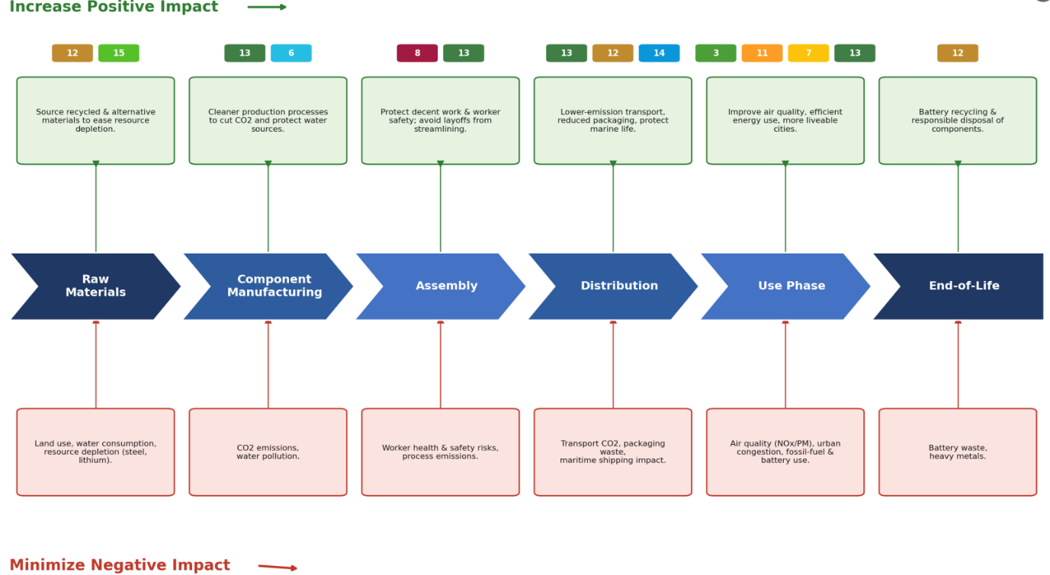

4. Ideas to Move Firm F Towards Sustainability
A minimum of 20 ideas have been generated to move Firm F toward sustainability. At least 10 were created by the team; AI was used to supplement the brainstorm and is referenced accordingly (Claude, 2026).

4.1 Full Idea List (20 ideas)
- Switch 100% of the domestic plant energy to renewable electricity (solar + wind). The IEA finds that scaling up renewables, energy efficiency and electrification with technologies available today can deliver more than 80% of the emissions reductions the world needs by 2030 (International Energy Agency, 2023)
- Launch a fully electric version of the Fab4WD model by Year 3. An electric model is one of the strongest decarbonisation levers available, because the lifecycle emissions of a medium-size battery-electric car are already about half those of an equivalent internal-combustion vehicle. (International Energy Agency, 2024).
- Introduce a battery take-back and recycling programme for end-of-life vehicles. It would keep critical minerals in circulation through high rates of material recovery, reducing dependence on environmentally damaging virgin mining (Ellen MacArthur Foundation, 2025).
- Partner with certified sustainable suppliers for steel and aluminium sourcing. Certification schemes such as ResponsibleSteel and the Aluminium Stewardship Initiative verify that producers manage greenhouse-gas emissions, water, biodiversity and labour rights across the supply chain (Aluminium Stewardship Initiative, n.d.; ResponsibleSteel, n.d.).
- Implement a carbon offset programme for emissions that cannot yet be eliminated. Reserving offsets for residual emissions reflects credible practice, since the Science Based Targets initiative requires companies to cut absolute emissions by at least 90% and to neutralise only the final, unavoidable share using permanent carbon removals (Science Based Targets initiative, n.d.).
- Redesign the Felony model packaging to use 100% recycled/biodegradable materials. Moving away from single-use materials eliminates avoidable waste and can also reduce greenhouse-gas emissions (Ellen MacArthur Foundation, n.d.).
- Introduce employee electric vehicle incentives and EV charging at all company sites. The IEA identifies charging availability at workplaces as an important enabler of EV adoption. (International Energy Agency, 2025).
- Publish an annual ESG report aligned with GRI Standards for full transparency. They are the world’s most widely used framework for disclosing environmental, social and economic impacts in a comparable and credible way (Global Reporting Initiative, n.d.).
- Reduce plant utilisation over-capacity by optimising production scheduling. The IEA notes that basic operational optimisation and energy-efficiency measures can deliver immediate emissions reductions at comparatively low cost (International Energy Agency, n.d.).
- Partner with city governments to provide EV fleet vehicles for public transport. With UNEP estimating that support for zero-emission buses can prevent thousands of premature deaths and avoid millions of tonnes of CO₂ emissions (United Nations Environment Programme, n.d.).
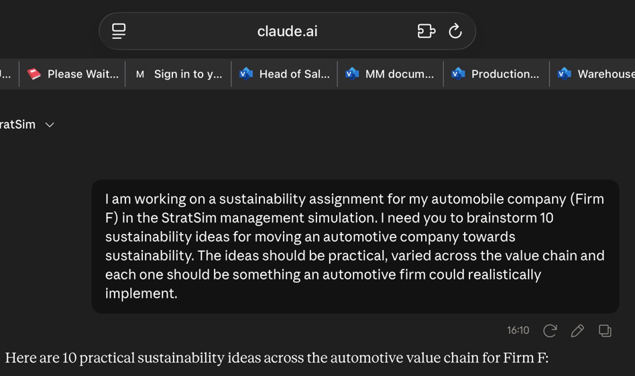

- Introduce water recycling systems in the manufacturing plant (AI-assisted idea — Claude, 2026)
- Develop an in-car eco-driving coach feature to reduce fuel consumption during use (AI-assisted — Claude, 2026)
- Explore bio-based plastics for interior parts to replace fossil-fuel-derived materials (AI-assisted — Claude, 2026)
- Create a supplier diversity policy prioritising fair-wage and safe-work suppliers (AI-assisted — Claude, 2026)
- Implement predictive maintenance AI in the plant to reduce energy waste (AI-assisted — Claude, 2026)
- Offer a vehicle subscription model to reduce total number of cars produced (AI-assisted — Claude, 2026)
- Introduce a co-ownership/car-sharing platform linked to Firm F's EV fleet (AI-assisted — Claude, 2026)
- Certify the manufacturing facility under ISO 14001 Environmental Management Standard (AI-assisted — Claude, 2026)
- Establish a Green Innovation Fund allocating 2% of net income to clean R&D (AI-assisted — Claude, 2026)
- Partner with NGOs on road safety campaigns to reduce crash fatalities linked to SDG 3 (AI-assisted — Claude, 2026)

5. Prioritisation of Ideas

5.1 Elimination of Trivial or Tolerable Impacts
After reviewing all 20 ideas against the risk matrix, the following were eliminated as addressing impacts that are either trivial in scale or tolerable given Firm F's current position:
- In-car eco-driving coach: addresses use-phase behaviour but relies entirely on end-user compliance; impact is marginal compared to structural product changes.
- Vehicle subscription model: commercially complex at this stage and only indirectly reduces production volume; impact on SDGs is uncertain.
- Road safety NGO partnership: valuable but does not address core production-level sustainability impacts.

5.2 Prioritisation Method
The remaining 17 ideas were prioritised using a weighted scoring method based on three criteria: (1) SDG Impact Score (1–5), reflecting how directly the idea addresses a Critical or High-risk SDG impact; (2) Feasibility (1–5), assessing how practical the idea is given Firm F's current financial position ($17.6M cash, $20.9M equity); and (3) Speed of Impact (1–5), measuring how quickly results can be achieved. The top 10 priorities are listed below.

Idea | SDG Impact (1–5) | Feasibility (1–5) | Speed (1–5) | Total
Switch to renewable plant energy | 5 | 4 | 3 | 12
Launch electric Fab4WD variant | 5 | 4 | 2 | 11
Battery take-back & recycling | 5 | 4 | 3 | 12
Sustainable supplier sourcing | 4 | 4 | 4 | 12
Publish annual ESG report | 4 | 5 | 5 | 14
City EV fleet partnership | 4 | 3 | 3 | 10
ISO 14001 Certification | 4 | 4 | 3 | 11
Green Innovation Fund (2% NI) | 5 | 5 | 4 | 14
Water recycling in plant | 3 | 4 | 4 | 11
Carbon offset programme | 4 | 4 | 4 | 12

6. Five-Year Strategic Action Plan (2026–2030)
The strategic action plan below is built on the top-prioritised ideas. It identifies specific objectives, concrete actions, measurable KPIs, and the relevant SDG for each year. All objectives are directly linked to Firm F's mission and vision. (Expand action explanation)

Year | Objective | Action | KPI / Target | SDG
Year 1 (2026) | Reduce manufacturing CO2 | Commission carbon audit; switch 20% plant energy to renewable solar. Procuring 20% of plant electricity from solar is a deliberately achievable first step that begins cutting the firm’s largest controllable emissions source while solar contracts and capacity are scaled up. | CO2 emissions down 10% | SDG 13
Year 1 (2026) | Establish ESG governance | Hire Chief Sustainability Officer; set internal carbon price $50/tonne. Appointing a Chief Sustainability Officer gives the strategy clear ownership and board-level accountability, ensuring sustainability is embedded in decision-making rather than treated as a side initiative. | ESG report published | SDG 8, 13
Year 2 (2027) | Electrify product line | Launch first fully electric variant (EV version of Fab4WD or Fantastic). This is the firm’s most material lever, because the bulk of a vehicle manufacturer’s lifetime emissions occur in the use phase, and battery-electric vehicles roughly halve those lifecycle emissions. | EV = 15% of unit sales | SDG 7, 13
Year 2 (2027) | Responsible sourcing | Audit top 50 suppliers for labour and environmental standards. Because raw-material extraction and component manufacturing carry the firm’s most severe social and environmental risks, auditing the highest-spend suppliers addresses the largest share of upstream impact first. | 100% top-50 audited | SDG 8, 12
Year 3 (2028) | Reduce fossil fuel use in operations | Install 5 MW solar on domestic plant; fossil-fuel vehicles in company fleet down 50%. On-site solar generation locks in long-term, low-cost clean electricity and reduces reliance on volatile grid and fuel prices, deepening the energy transition begun in Year 1. | Plant fossil fuel use -30% | SDG 7
Year 3 (2028) | Urban congestion partnership | Partner with city of operations for fleet EV sharing scheme. Shared electric fleets reduce the number of private vehicles needed for the same mobility, easing congestion and improving urban air quality where the firm operates. | 500 EV fleet units deployed | SDG 11
Year 4 (2029) | Circular economy | Launch battery take-back programme; achieve 80% recycled material in batteries. Recovering end-of-life batteries closes the materials loop, returning lithium, cobalt and nickel to production and reducing both hazardous waste and the need for new mining. | Battery recycling rate 80% | SDG 12
Year 4 (2029) | Zero waste to landfill | Divert 90% of manufacturing waste via reuse or recycling. Treating manufacturing waste as a recoverable resource rather than disposal cuts environmental harm and often lowers cost through material recovery and reduced landfill fees. | Waste to landfill -90% | SDG 12
Year 5 (2030) | Net-zero operations | Offset remaining emissions; achieve carbon-neutral manufacturing plant. After years of absolute reductions through renewable energy and efficiency, only a small residual remains, which is neutralised with high-quality carbon removals in line with recognised net-zero practice. | Scope 1+2 net-zero | SDG 13
Year 5 (2030) | 50% EV product portfolio | All new model launches to be EV or hybrid only. A launch policy of EV or hybrid only ensures the portfolio shifts permanently toward low-emission vehicles, compounding the use-phase emission savings achieved since Year 2. | Fossil-fuel km driven -50% | SDG 7, 13

6.1 Link to Mission and Vision
Firm F's mission is to provide high-quality, innovative vehicles that deliver exceptional value for customers while minimising harm to the environment and society. The five-year strategic action plan directly operationalises this mission by targeting the most critical sustainability impacts identified in the SDG value chain analysis.
The first two years focus on governance and product electrification — ensuring that the company builds the institutional capability (Chief Sustainability Officer, carbon pricing, ESG reporting) and product innovation (EV model launch) needed to sustain long-term change. The middle years address operational efficiency and circular economy practices, targeting SDG 12 (responsible consumption) and SDG 7 (clean energy). The final years of the plan align with global 2030 targets under the Paris Agreement, aiming for net-zero Scope 1 and Scope 2 emissions in manufacturing.
This trajectory is financially credible. Firm F ended Year 8 with $17.6M in cash and $6.1M net income (StratSim Management, Year 8 Income Statement). A Green Innovation Fund allocating 2% of net income (~$122K annually) provides a dedicated, low-risk starting mechanism. Larger investments, such as the solar plant installation and EV product development, are supported by the company's strong balance sheet ($26.9M total assets, $20.9M equity) and positive operating cash flow of $7.1M (StratSim Management, Year 8 Cash Flow Statement; Balance Sheet).

7. Bibliography
Claude. (2026). Brainstorming sustainability ideas for the automobile industry [AI-generated content]. Anthropic. https://claude.ai
Environmental Protection Agency [EPA]. (2023). Greenhouse gas emissions from a typical passenger vehicle. United States Environmental Protection Agency. https://www.epa.gov
European Commission. (2020). Circular economy action plan: For a cleaner and more competitive Europe. European Commission. https://ec.europa.eu
Intergovernmental Panel on Climate Change [IPCC]. (2022). Climate change 2022: Mitigation of climate change. Contribution of Working Group III to the Sixth Assessment Report. Cambridge University Press. https://doi.org/10.1017/9781009157926
International Energy Agency [IEA]. (2021). Net zero by 2050: A roadmap for the global energy sector. IEA. https://www.iea.org/reports/net-zero-by-2050
StratSim Management. (Year 8). Company dashboard, income statement, cash flow statement, balance sheet, product contribution, manufacturing, competition/manufacturing, and portfolio analysis [Simulation data]. Interpretive Simulations. https://app6.interpretive.com
United Nations Environment Programme [UNEP]. (2021). Waste management outlook for mountain regions: Sources and solutions. UNEP. https://www.unep.org
World Health Organization [WHO]. (2022). Ambient (outdoor) air pollution. WHO. https://www.who.int/news-room/fact-sheets/detail/ambient-(outdoor)-air-quality-and-health
Aluminium Stewardship Initiative. (n.d.). Responsible sourcing. https://aluminium-stewardship.org/drive-change/responsible-sourcing
Ellen MacArthur Foundation. (n.d.). Our vision for plastics in a circular economy. https://www.ellenmacarthurfoundation.org/plastics-vision
Ellen MacArthur Foundation. (2025). Exploring the circular economy opportunity for critical minerals. https://www.ellenmacarthurfoundation.org/critical-minerals/overview
Global Reporting Initiative. (n.d.). The global standards for sustainability impacts. https://www.globalreporting.org/standards/
International Energy Agency. (2023). Net zero roadmap: A global pathway to keep the 1.5 °C goal in reach. https://www.iea.org/reports/net-zero-roadmap-a-global-pathway-to-keep-the-15-c-goal-in-reach
ResponsibleSteel. (n.d.). Standards. https://www.responsiblesteel.org/standards
Science Based Targets initiative. (n.d.). The corporate net-zero standard. https://sciencebasedtargets.org/net-zero
United Nations Environment Programme. (n.d). Electric buses https://www.unep.org/topics/transport/electric-mobility/electric-buses

